**Lesson 9 Demo 1**

**Troubleshooting Kubernetes Cluster**



Steps to be followed:

1. Obtaining the cluster information
2. Troubleshooting using the dumps
3. Getting help on dumps
4. Getting cluster-info dump of a specific namespace
5. Getting errors and warnings

**Step 1: Obtaining the Cluster Information**

1. Type the following command to obtain the cluster information:

***kubectl cluster-info***

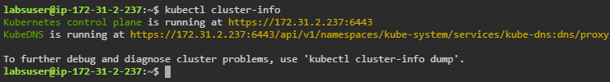

**Step 2: Troubleshooting Using the Dumps**

1. Execute the following command to obtain the cluster dump information:

***kubectl cluster-info dump***



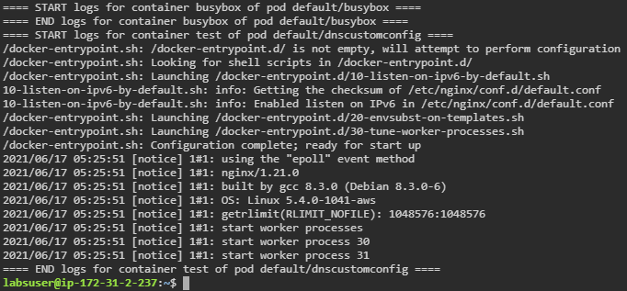

**Step 3: Getting Help on Dumps**

1. Execute the following command to view the dump options and help page:

***kubectl cluster-info dump --help***

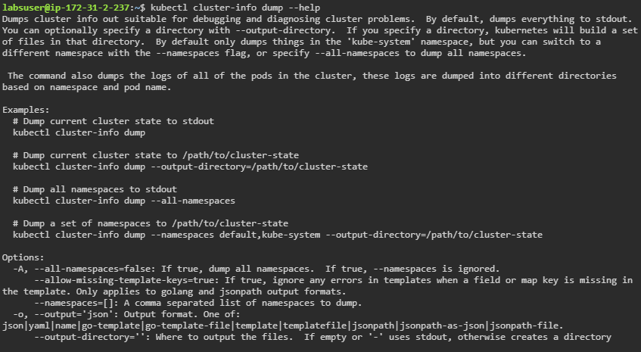

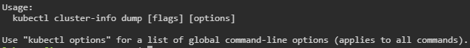

**Step 4: Getting Cluster-info Dump of a Specific Namespace**

1. The following command provides a dump on a specific namespace:

***kubectl cluster-info -n <namespace> dump***



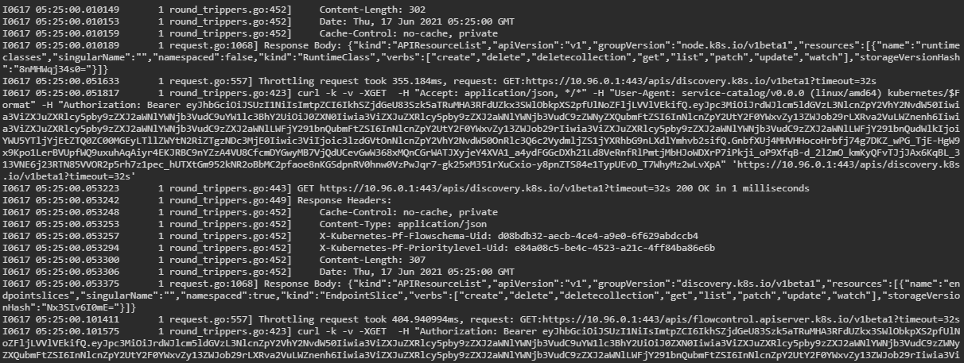

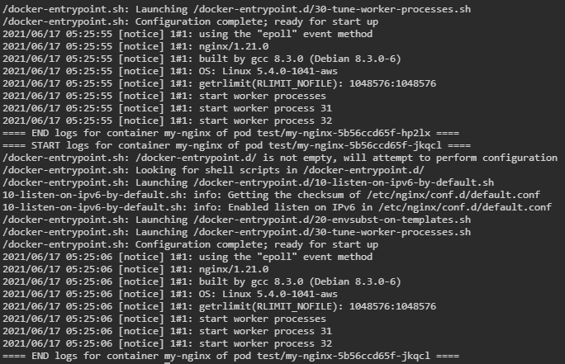

**Step 5: Getting the Errors and Warnings**

1. Obtain the relevant errors and warnings using the following command:

***kubectl cluster-info -n default dump | grep Warning***

